Specifications

Project Name:

**CvMaker**

Project Background:

People are struggling with using word applications and photoshop and illustrator to create their own cv and there a lot of missed opportunities that missed because people they have not a cv yet so CvMaker fix this Issue by creating cv by just inputting data

Database Schema:

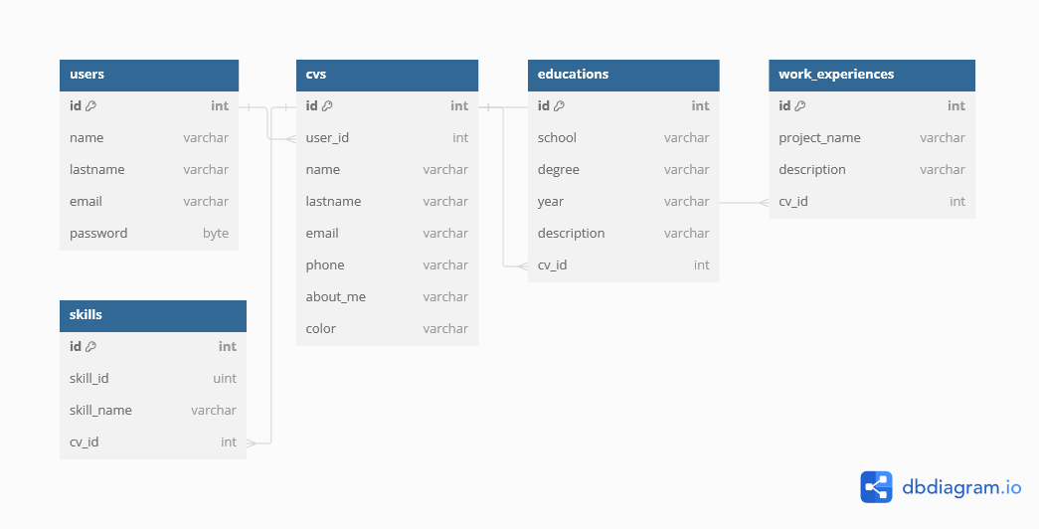Technologies:



**Spring Boot & Jpa:**

Spring Boot is a fullstack framework I used it in the backend to create an api



**PostgreSql :**

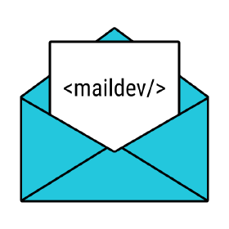An Sql Database used to store data

**Maildev:**

A server to send an email for development purposes just for testing

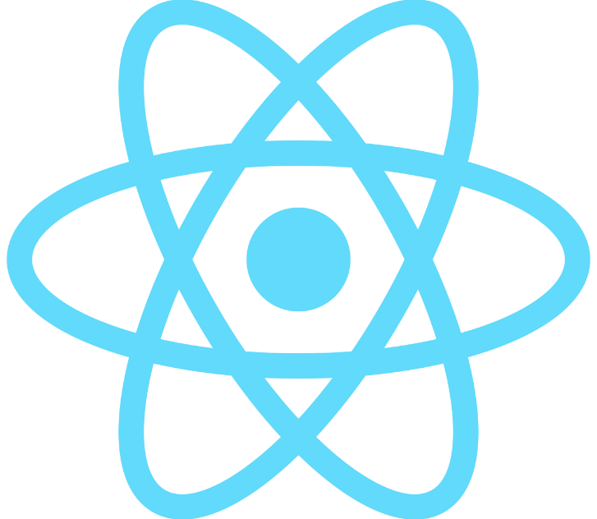

**ReactJs:**

A Front-end Library that allows you to create a robust web interfaces



**Spring Security:**

It used to secure Spring applications

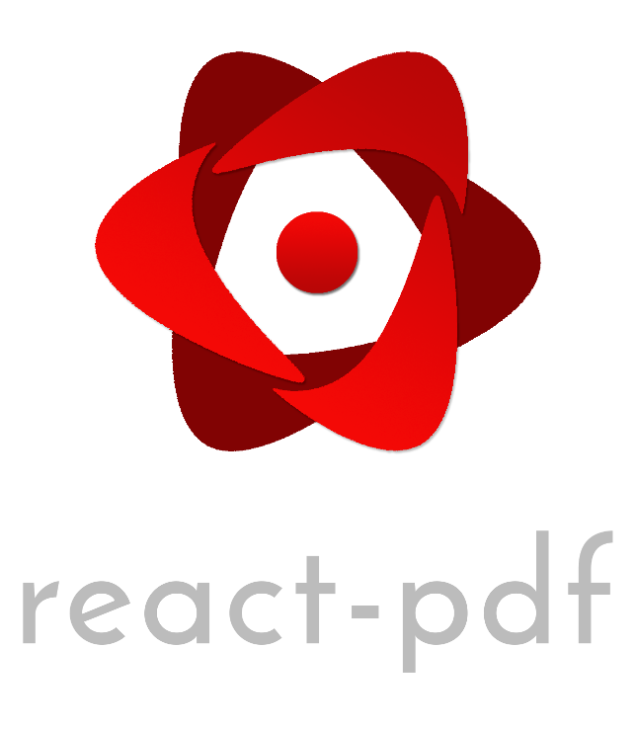

**React-pdf:**

It is a tool used to generate pdf from a react existing code

**TailwindCss:**

Is a tool that offers you an easy way to design your html using a few words to create a full block of css